**Bayesian Network with Temporal and Spatial Correlation among Sensors**

Karthik Bangalore Mani

Department Of Computer Science

Illinois Institute of Technology

May 4, 2016

**Abstract**

The goal of this Phase is to encode the temporal and spatial correlation among sensors. The mean of a sensor at a timestamp is given by :

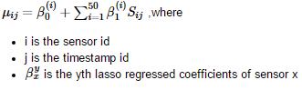

The variance of a sensor at a timestamp is given by :

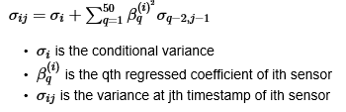

**Phase III :Results and Discussion:**

For the Window Inference, below Mean Absolute Errors were obtained for the different datasets:

|  |  |  |  |  |  |
| --- | --- | --- | --- | --- | --- |
|  | **Budgets** | | | | |
|  | **0** | **5** | **10** | **20** | **25** |
| **Temperature** | 2.3580283488 | 1.40551284707 | 0.963139344009 | 0.507008480598 | 0.388757264106 |
| **Humidity** | 5.20400735684 | 2.91873540345 | 1.71199837154 | 0.823603812128 | 0.563036486245 |

For the Variance Inference, below Mean Absolute Errors were obtained for the different datasets:

|  |  |  |  |  |  |
| --- | --- | --- | --- | --- | --- |
|  | **Budgets** | | | | |
|  | **0** | **5** | **10** | **20** | **25** |
| **Temperature** | 2.3580283488 | 0.776612864088 | 0.632531210788 | 0.406946347889 | 0.330723961793 |
| **Humidity** | 5.20400735684 | 2.09154217564 | 1.4122045059 | 0.842476668095 | 0.633271897529 |

**Comparison of the results of Phase I, Phase II and Phase III:**

* **Phase I:**

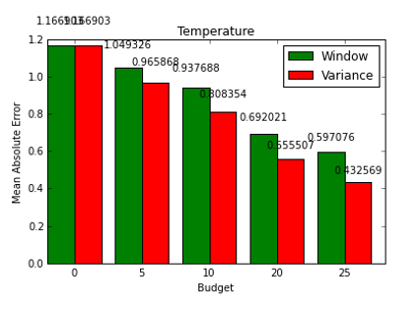

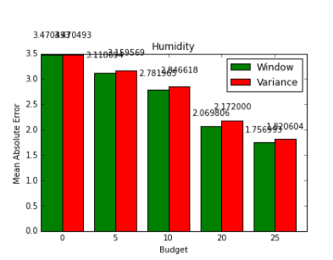

* **Phase II :**
  + **Window:**
* **Phase III :**
  + **Temperature:**

**Humidity:**